Name:………………………………………………..…. Date:………………………………………………………
Crystal chemistry
Liquid crystals
Liquid crystals are exactly what they say they are – liquid and crystal! They are not both liquid and crystal at the same time – but these substances switch easily between being liquid and solid when electricity is passed through them.
Did you know what a liquid crystal is?
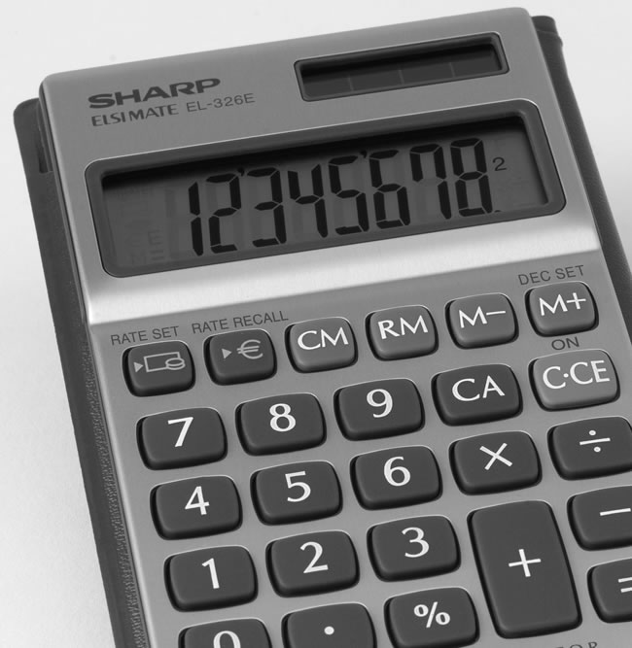 | 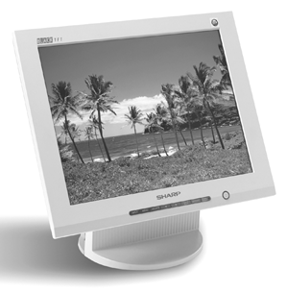
Liquid crystal display used in a calculator  Reproduced with kind permission of  Sharp Consumer Electronics. | Liquid crystal display used in a computer screen  Reproduced with kind permission of  Sharp Consumer Electronics.
Anyone who has used a calculator has seen liquid crystals. They are the substances which make the display work. They were first discovered in about 1888 by an Austrian scientist called Friedrich Reinitzer. He noticed that crystals of a substance called cholesteryl benzoate were cloudy at one temperature, clear and colourless at another and turned blue just before forming crystals. Over 80 years later, scientists made the first Liquid Crystal Display (LCD). Liquid crystals are complicated, long molecules like this:-
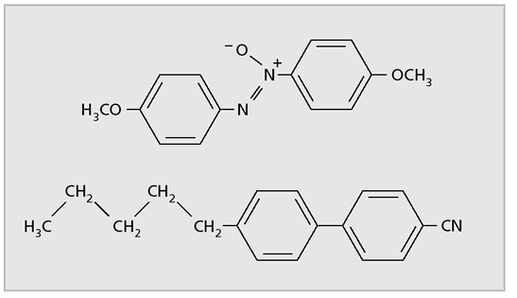
Molecules of liquid crystals
The molecules naturally have a twisted arrangement (see figure below). When an electric current is passed through, the twist is removed, so the molecules are in straight lines.
continued on next page



Crystal chemistry
continued from previous page

In an LCD, the liquid crystals are sandwiched between two polarisers set at right angles to each other. A polariser allows light to pass through in one direction only (they are used in polarising sunglasses). Normally, no light can pass through polarisers set like this. But when twisted liquid crystal molecules are set between them, light can pass through. When the twist is removed, light can not pass through and the LCD appears black.
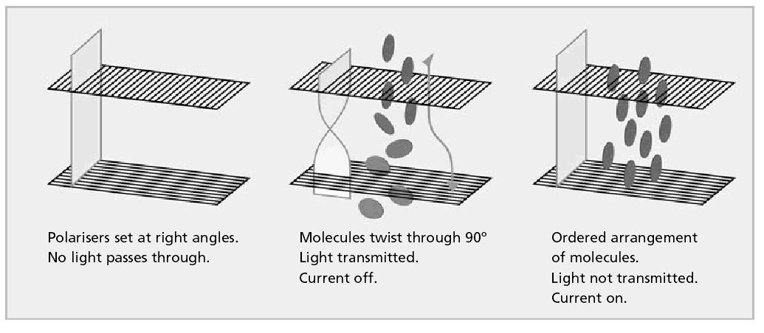
When the current is switched on, the molecules line up and no light passes through. When the current is switched off, the twist returns and light can pass through. On the LCD on a calculator, each place where a number appears is broken into seven different sections. Switching the tiny electric currents to each section gives the different numbers. There are many different types of
liquid crystal.
What you do
Now read this text and answer the questions.
Flipping flakes! It's a liquid crystal
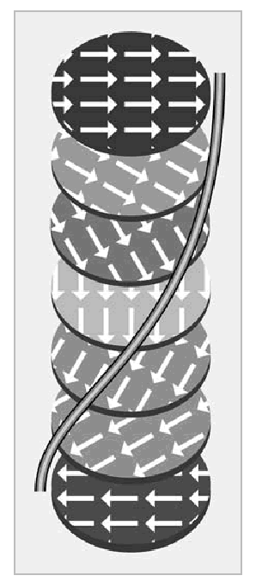 | Flipping flakes: new liquid crystals can change  colour. Each layer points in a slightly different direction,  described by a helix

continued on next page

Crystal chemistry
continued from previous page

Imagine having a piece of paper which changes colour when you pass a small electric current through it or seeing a helicopter turn red when it comes into land. When the latest liquid crystals are fully developed, these ideas could be real!
Researchers at the University of Rochester in the USA are working with liquid crystals that reflect red, green or blue light when they are switched on. Normally, liquid crystals appear black or grey, as they are just one group of molecules. To make different colours, the trick is to use liquid crystals bonded together in layers and with layers stacked together in flakes. In the flake, each layer is rotated from the one above, so the molecules in the layers point in slightly different directions (see diagram). This means that through a flake, the layers can rotate through up to 360 °C. Changing the thickness of the layers affects the light reflected by the flake.
When electricity is passed through the flakes, they can flip and rotate, creating different colours. To make letters, pictures and numbers, a large number of flakes need to start off and end up in the same position. At the moment, researchers are working on controlling the flakes' flips and rotations. Also, the flakes are in an oily liquid between two glass plates, which is not quite as flexible as a piece of paper, but there is a possibility that the flakes could go into a flexible computer screen which folds up into a pocket!
The scientists also think that the flakes could be put into paints. This would mean that you could change the colour of your wall by the flick of a switch. Aircraft could be painted so that flicking a control would flip the flakes in the paint, causing a colour change. Paper could be made so that it changes colour going through a printer.
Scientists think that electronic paper may be available in about two years and practical devices in five years.
Questions
1. What are the main differences between these liquid crystals and those used in calculators at the moment?
……………………………………………………………………………………………………………….……………………………………………………………………………………………………………….……………………………………………………………………………………………………………….……………………………………………………………………………………………………………….
2. What problems must still be solved before these liquid crystals can be used? ……………………………………………………………………………………………………………….……………………………………………………………………………………………………………….……………………………………………………………………………………………………………….……………………………………………………………………………………………………………….
continued on next page

Crystal chemistry
continued from previous page

3. List the three possible uses for the flakes suggested in the article. What other uses can you think of where it might be useful for a quick colour change to happen? ……………………………………………………………………………………………………………….……………………………………………………………………………………………………………….……………………………………………………………………………………………………………….……………………………………………………………………………………………………………….……………………………………………………………………………………………………………….……………………………………………………………………………………………………………….……………………………………………………………………………………………………………….……………………………………………………………………………………………………………….

